**IoT based Application Platform**

Team Members:

Snigdha Verma

Avanti Gupta

Ritika Sharma

Nitin Bharadwaj

Krishnakanth Reddy

Shiv Rama Krishna Kurapati

Kulvinder

Mohit Aggarwal

Yashasvi Girdhar

**1. Introduction**

IoT comprises things that have unique identities and are connected to the internet. The project is intended to IoT based sensor monitoring system .

Sensors are used to get physical parameter data like temperature, displacement, acceleration, flow,sound,vibration,pressure,motion or pollutants which are used to make decisions, control systems etc after being converted to an electrical equivalent which is easily input into a computer or microprocessor for manipulating, analysing and displaying.

Since the data collected by different sensors is in different formats , it is automatically handled and classified by the platform and is contextualised .

An API is exposed to the developers of the application by creating a level of abstraction for them and they can proceed irrespective of the details of information being collected by the sensors and its processing.

**2. Functional overview**

**2.1 Key Functions:**

* Collection of data from various heterogeneous sensors and gather the details of each sensors dynamically.
* Security check is applied to maintain the confidentiality of information.
* Real-time data processing and providing the valuable information in lesser time.
* System is dynamic in nature so minor changes in sensor reading are tracked and taken care of.
* Creation of protocol header so as to send it across the communication media to the filter server with ease.
* Maintenance of Sensor Type Repository so as to identify the type of data the sensor sends.
* It provides a layer of abstraction to a developer who is building an app using our platform.
* Usage of RESTful web services for communication over TCP/IP protocols.
* Storage of all the sensor types. The database used is MongoDB.
* Classification of sensed data on the basis of their type and then sending it to the respective application that requests it.

**2.2 Block Diagram**

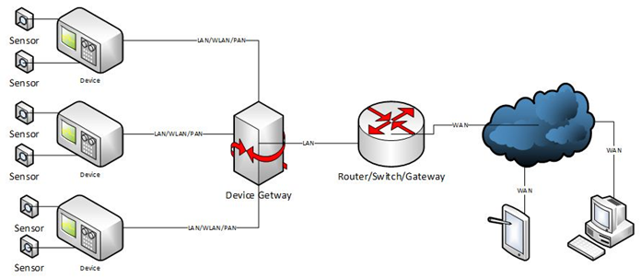

**2.3 Component Description:**

**Sensors**

Sensors that detect or measure a physical property and convert it into some kind of electronic representation. The connection between the Sensor and the Device can take on a number of different configurations. The hardware connection could be digital (e.g., a temperature sensor may use a serial protocol to transmit the values in Centigrade) or it may be analog which requires an Analog to Digital convertor in the Device.

**Device**

The Device provides the intelligence needed to work meaningfully with the data provided by the attached Sensor(s).

**LAN/WLAN/PAN**

From the Device to the cloud, network-type protocols are used to connect the pieces together. This leg of the connection represents the network in a geographically small area (typically a building) and is the glue which allows Devices and Device Gateways to communicate.

**Device Gateway**

The Device Gateway is the aggregation device for an IoT deployment and typically has significant computing and networking capability. In some configurations, the Gateway may also connect directly to Sensors (in this case the Gateway is also a Device).

* It performs the following functions
* It aggregates data from multiple devices
* It creates the ‘switch fabric’ to route data between devices
* It may provide or enhance security
* It provides additional processing (computing) capability

**Router/Switch/Gateway**

This component serves as the Gatekeeper between the in-premise network and the Internet. Its main purpose is to partition the network into two parts; the secure/trusted network (on the left in the diagram above) and the insecure/un-trusted network.

**WAN**

The WAN is typically what we commonly call the Internet. It’s the network fabric which allows all sorts of devices to communicate over the public network infrastructure. The main attribute of the WAN is that it is outside the premise (building) and is typically used to connect systems which are not physically close.

**Presentation Devices**

At the end of the day, what do we do with all that information we have collected? One obvious thing is to display the information via a dashboard via gauges, charts and red and green lights. Dashboards have to be hosted on some kind of display, we call that the Presentation Device. It could be a desktop computer running a thick (native) or thin (web based) application, a tablet or a smartphone. It could even be a purpose-built device like a retail kiosk, intelligent vending machine or a control panel on a piece of heavy machinery or industrial equipment.

**3.Use Cases**

* Retail & Logistics - Beacons are indoor positioning systems, which can interact directly with modern smart phones, e.g. using Bluetooth Low Energy (BLE).a user might create a shopping list on his smartphone and share it with the store app. Upon entering the store, the store app will display a map to the customer, which highlights all the products on his shopping list. Every time the customer gets close to a position where a group of products from his shopping list is located, the app will notify him and make a recommendation for a particular brand. At the check-out point, the system could identify all the products in the shopping cart automatically via RFID, create and confirm an invoice, and use the smart phone to process the payment. The store’s inventory system is automatically updated when the checkout process is complete.
* Sound Sensor - In a theater or an auditorium ,automatic random sensing can be done based on the intensity of sound.This means based on the surrounding environment , audience voice and other disturbances the volume (sound modulation) of the sound system or the mike system should either be increased or decreased.
* Smart baby monitor - Get real-time audio and insights about baby’s sleep activity right on your smart device:
* Know when he cries through sound sensor.
* Track breathing activity through respiratory sensors.
* Check baby’s body position to see how he is sleeping and be notified if he rolls over through motion sensor.

Working:

* The sensors send information about baby’s breathing, body position, sleep activity, and skin temperature to devices.
* The devices streams data and live audio to the cloud.
* You receive real-time insight about baby on your smartphone.
* Security Frameworks  
  Security frameworks play a vital role in any architectural design of important buildings. For developing the security framework for such buildings we can deploy temperature sensor in the the vicinity of the building such that we can have segregation of the areas of building into various zones, once this is decided the data collected from the sensors can then be used to check for the alerts i.e., if the temperature around the sensitive areas is more than expected range then the presence of an invading object can be concluded to significantly high probability. In short the sensor data can help us create the heat map of any building structure. And using this map we can monitor only those areas where the activity seems to be varying from the normal range.
* Habitat Establishment for endangered species  
  The various wildlife sanctuaries all over the world face this problem of habitat establishment for various species such as crocodiles for instance. Their eggs require certain temperature conditions for healthy development although this can be managed but requires too much of manual intervention which off course hampers with the natural cycle thus this can be very important use case for the temperature sensors, which can be deployed to create conducive environment for their healthy development.
* Storage houses for grains  
  It is estimated that the cost of production of grains such as wheat, rice etc is equal to their storage cost and hence there is an hike for retail prices.The storage conditions is very important for these produces as they tend to have inbed insects and other organisms that can potentially destroy the entire yield. Currently there is only central temperature conditioning irrespective of the building structure and regardless of the areas of the building that tend to have less sunlight or tend to be humid due to the construction structure thus no differential control is provided, thus for this these sensor can be used to obtain the exact conditions and take appropriate action for condition maintenance and to at lower manpower cost.

**Primary Use Case**

**Grain Temperature monitoring**

Temperature is the key to safe grain storage. When grain goes out of condition, regardless of the cause, there is always an unusual increase in temperature. For those who manage grain, temperature is the best indicator of grain quality. Grain is a living organism. Like other living things, it breathes and it may become sick. Excessive moisture, high temperature, and poor grain condition are generally considered the most important factors that lead to trouble in stored grain. The three specific causes of heating are respiration of the grain itself (metabolism of grain), microorganisms such as fungi and bacteria, and insect infestation.

**Components:**

**Temperature Sensors:** Check the temperature of the storage bin every fixed time interval (say 2 weeks). Measure temperature by using temperature sensing cables that are permanently installed or by probing the grain with an electronic sensor device.

A continual increase in temperature is a warning that must be heeded, especially if one spot in the bin is heating faster than the bin as a whole. Experience indicates that once heating starts, it continues to increase at an increasing rate until cooling is applied.

**Humidity Sensors:**  Check the humidity level of the stock at regular intervals and notify the central server whenever the range exceeds or goes beyond a certain range.

**Central Server:** Central server receives all the data from both the temperature sensors and the humidity sensors in timely manner and maintains a table of all the statistics/current condition at its end which contains temperature and level of humidity . After gathering the data, it then sends it to filter server via communication channel.

**Internet:** It is the most important communication component in any such model. All the information, request or response generated by various components are transmitted via internet. It makes possible for the user to control the things from anywhere around the globe.

The information may then be gathered by API users (administrators) to monitor the levels of humidity and regulate the temperature as required to maintain the health of the stock.

**Information Model:**

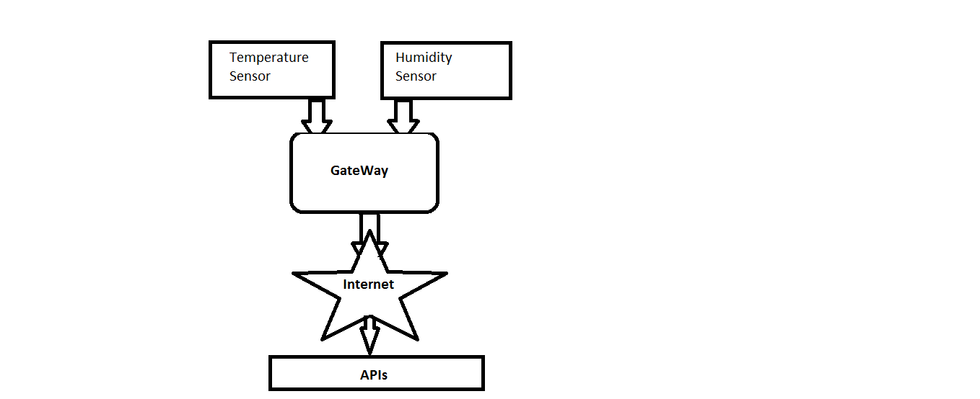

**Processing logic on the backend:**

Both type of sensors are connected to the gateway(Raspberry Pi) which uses communication protocols to forward information gathered to the master / filter server . TCP/IP protocol is used.

Since the sensors keep sending updated conditions of the grain stock the information can be updated in a timely manner say daily basis and the master server can keep updating its tables .

The information gathered from each sensor is stored corresponding to its type and sensor ID in the Sensor Registry.Hence, the processed information can be forwarded via internet to the developer’s application which is then used by users (grain stock administrator) for regulating the stock’s temperature and humidity levels as and when required for longer life of the grains.

**User View:**

The users view can be customized to fetch important information categorized in a manner useful for his purpose such as :

* **Notification :** Whenever any information is fetched from the central server, and if that value is above some threshold, it can be notified to the user using notification tone.
* **Dashboard:** This area is used to display the information sent by the central server.
* **User Settings:** User can give the instructions increase/decrease in temperature and humidity through the dashboard in the screen.

**4.Definition & scope**

The project aims at developing an efficient framework for developing an application independent Generic IoT Framework with well-defined Reference Architecture to achieve interoperability between the various devices/application developed in multi-vendor scenario to achieve cost advantage and pass this advantage to the user group for its mass scale deployment and

applicability .

The platform abstracts the middleware of the system and the APIs are exposed to the developers.

1. **Input Subsystem –** It consists of a collection of sensors which could be heterogeneous.
2. **Control Subsystem-** The gateway, communication channel and the filter server together constitute a control subsystem.
3. **Output/Application Subsystem-** It consists of the application programming interface.

**Device Interface with system**

The device interface is provided using a API to both the administrator of the system and to the developers.

Using the device API the developers can monitor the sensors,their secure communication, reconfiguration in case of sensor failures,their addition and deletion.

Moreover,the developers use the API to receive values/information gained from various sensors after their classification and conversion to required formats.

**Registry & Repository**

Sensor registry stores the data sensed by the sensors like temperature, displacement, acceleration, flow,sound,vibration,pressure,motion or pollutants etc.

Sensor repository contains the details of each sensor and the type of data sensed by it. For example heat sensor, temperature sensor, sound sensor ,motion sensor ,pressure sensor etc.

**Logic server (aPaaS)**

aPaaS , Application platform as a service is a cloud service that offers development and deployment environments for application services.

**Location Service**

Location Services will provide developer the location of the sensors from which developer intends to receive the data. Accordingly developer can make use of this information so as to develop domain specific application**s.**

**Mobile Interface**

Mobile interface will be provided through an android application which receives data from the application programming interface (API) via a filter server.

**5. Interactions and Interfaces:**

Interactions involved across subsystems:

Sensor-Device Gateway Interaction - Socket programming is used for interaction between sensor and gateway. There is a collection of gateways which are simulated using a RaspberryPi system. The sensors send their sensed data to the gateways they are connected and all these gateways then send the collected data to the Master Gateway which does further processing and sends it across.

Gateway-Filter Server Interaction - RESTful services are used for interaction between Gateways and filter server. The Master Gateway creates a protocol header containing the required information to transfer across the communication medium. The communication medium is the Internet and the data is sent over the TCP/IP protocol. The message header containing information like id, type, location etc. is transferred to filter server for further processing.

Filter Server-Application- Since filter server receives data of all the types of sensors that are installed in the area, it must filter out only those that are requested by the application, i.e. an application requesting temperature information must not be shown humidity information and vice versa. For this, the filter server consults the sensor type repository and then sends only valid data to the application. Also, the filter server validates the source of generation of data. This is primarily required from the security standpoint otherwise malicious data might be shown to the user.

**6. Overview of modules, functional overview and their capabilities:**

The proposed project works on the theme of Internet of things as described above, hence the project is divided into three basic modules that are as described as follows. There will be a module that handles the interrupts from the sensors deployed in the physical environment.This module would get us the physical parameters required for the action that is to be taken on filed.The module would to process the data collected the first modes that is the sensor data and would convert the data into useful information so as to decide the future course of action. Once the collected data is processed the third module would send the interrupt (signal) to the sensors deployed or to the machine which is to be manipulated based on the given information. Thus this would be the broad division of the project into the modules.Although the exact module definition will be finalised once the type and other details of the sensors is clear to start working on the project topic.